Combined Deep CNN-LSTM network for Pneumonia Classification using Chest X-RAY images

**Dept. of Electronics and Telecommunication, Pimpri Chinchwad College Of Engineering ,Pune**

# INTRODUCTION Result

Pneumonia accounts for 14% of child mortality worldwide, especially in low-income regions due to overcrowding and limited healthcare. Early detection via chest X-rays (CXR) is crucial, but manual diagnosis lacks consistency.

This study leverages deep learning, using an ensemble model combining CNN and Inception-V3 for improved pneumonia classification. Transfer learning enhances accuracy, while data augmentation mitigates overfitting. The model's performance is compared against single models and state-of-the-art methods.

# Objectives

* Analyze and diagnose the key factors affecting the system under study.
* Develop methodologies to enhance system performance and efficiency.
* Implement and test proposed solutions under various conditions.
* Evaluate results through quantitative and qualitative analysis.

# Methodology

* A hybrid CNN-LSTM model is used—CNN extracts spatial features, while LSTM captures sequential dependencies. Batch normalization, dropout, and max pooling enhance performance.
* Convolutional layers extract spatial features from 128×128 RGB images, capturing patterns, textures, and hierarchical representations. Pooling layers reduce dimensions while retaining essential details.
* A fully connected layer maps learned features to three classes (No Disease, Bacterial Pneumonia, Viral Pneumonia), followed by a Softmax layer for probability-based classification.

Training Accuracy: 84.6961%

# Application

* + Automated Pneumonia Diagnosis**:** Helps radiologists detect pneumonia from chest X-rays with high accuracy, reducing manual workload.
  + Telemedicine & Remote Healthcare: Enables early pneumonia detection in remote areas where expert radiologists are unavailable.
  + Smart Hospital Systems: Can be integrated into

AI-powered diagnostic tools for faster and more efficient patient screening.

* + Medical Research & Drug Development: Assists researchers in analyzing pneumonia progression and treatment effectiveness using medical imaging.
  + Mobile Health (mHealth) Application**s:** Can be integrated into mobile-based diagnostic apps, allowing users to upload chest X-rays for AI-assisted preliminary pneumonia detection.

# Conclusion

* + High Accuracy**:** The CNN-LSTM model improves pneumonia detection by capturing both spatial and sequential dependencies.
  + Robust Learning**:** CNN extracts features, while LSTM enhances pattern recognition across lung regions.
  + Scalable Solution**:** Future improvements like transfer learning and attention mechanisms can further enhance performance.

# Reference

Rajpurkar et al. (2017) – *CheXNet: Radiologist-Level Pneumonia Detection on Chest X-Rays.* [arXiv:1711.05225]

**I**slam et al. (2020) – *CNN-Based Abnormality Detection in Chest X-Rays.* [DOI: 10.1007/s13755-020-00112-7]

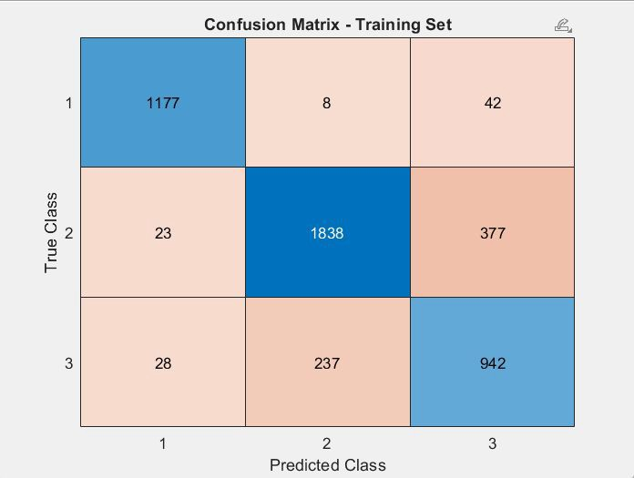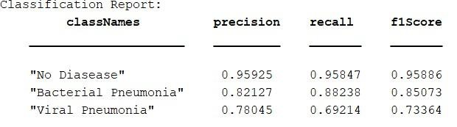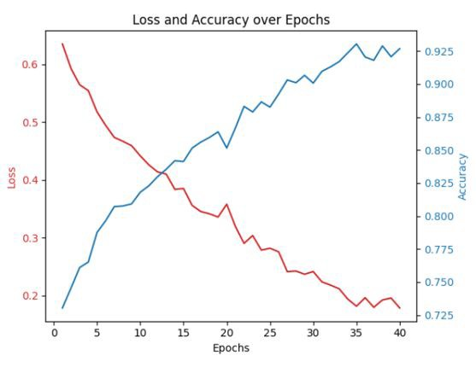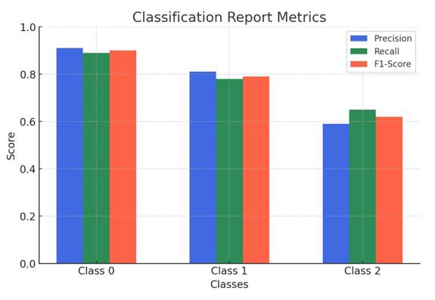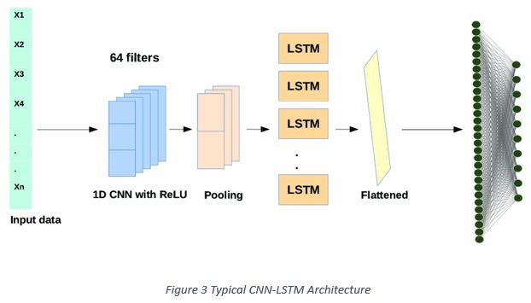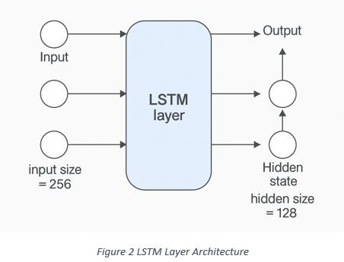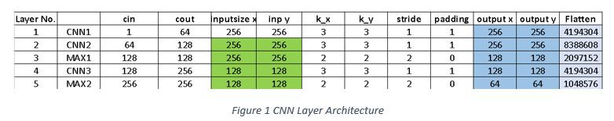

**RESEARCH POSTER PRESENTATION TEMPLATE © 2019**

[**www.PosterPresentations.com**](http://www.PosterPresentations.com/)